***Srs (software requirement specification )***

***[Online movie ticket reservation]***

***INTRODUCTION :***

*This project is aimed to develop an online ticket reservation system for cinema halls. The ticket reservation system is an Internet based application which can be accessed through net and cannot be accessed without internet. This application contain some basic terms and conditions.*

***SCOPE :***

* + *To allow user to login and get OTP to successfully access the application.*
  + *The customer will able to gather the information about the new released movie.*
  + *It allow customer to book online ticket within 5 minutes.*
  + *In this application customer can rate the movie .*

***LIMITATION :***

* *The current Online booking system does not support refund facility but in future it may support.*
* *The customers are not able to book a ticket before one day.*

***REQUIREMENT :***

* + - *Functional requirement****.***
    - *Non-Functional requirement.*

***FUNCTIONAL REQUIREMENT:***

***The customer should be able to***

* + - * + *Not able to reserve before one day.*
        + *Able to choose seats which are available for certain classes.*
        + *Give details about the credit & debit cards.*
        + *Receive notification from the application about the movie update.*

***NON-****FUNCTIONAL REQUIREMENT:*

*The application is a web based application which runs on a device browser.*

*This application is available in web page for all the time.*

*Maintenance is typically done after the software development has been completed.*

*The web page is based on ‘C’ language ,the application is portable.*

***SOFTWARE REQUIREMENT:***

* + - * ***OS : windows(7,8,10,11)***
      * ***Script : c ,html***
      * ***Ram : 2 gb***
      * ***Speed : 1.1GHz***

***SYSTEM DESIGN***

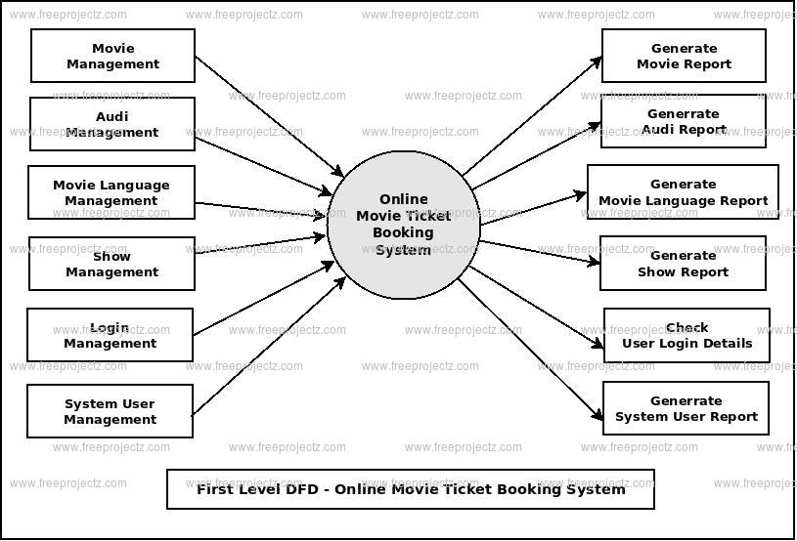

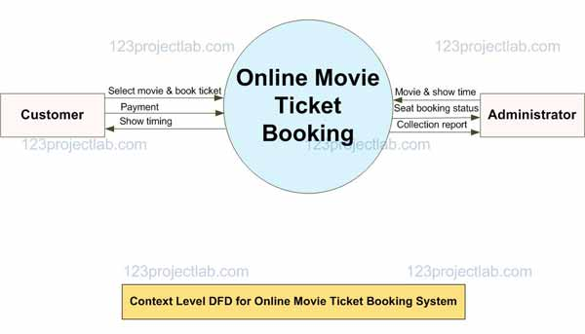

***CONCLUSION:***

*This paper proposes the web based online system which saves yours time for buying ticket by waiting in queue. This web based application can further implemented in your phone .This system is more secure as it is developed on C language****.***

***Done by***

***Arulraj***

***Gokulanandh***

***Vishnuvardhan***

***Bhuvanesh***